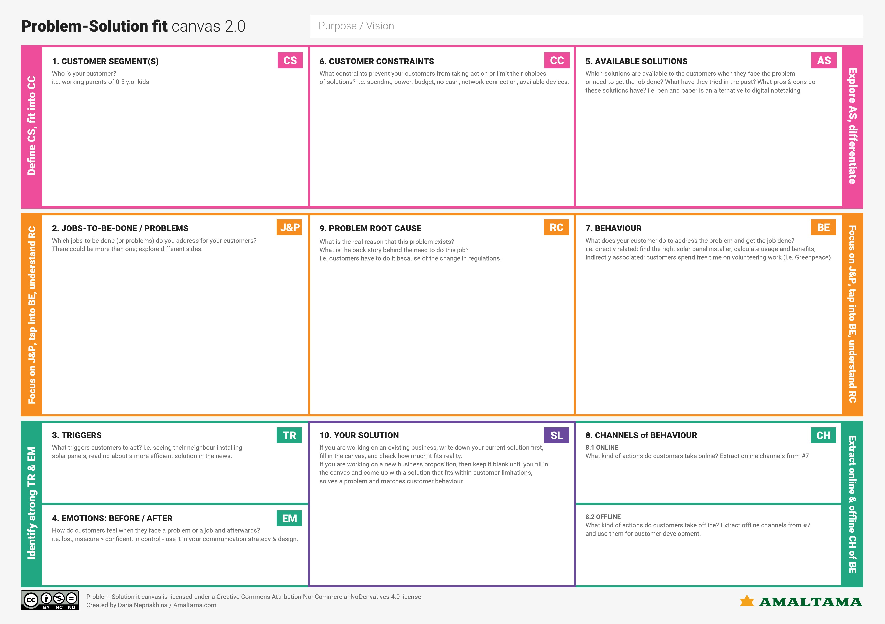c [Grab your reader’s attention with a great quote from the document or use this space to emphasize a key point. To place this text box anywhere on the page, just drag it.]

* Local sponsorship
* Reach your customer through direct marketing
* Speak to their values
* Listen more than you talk
* Maintaining eye contact
* Touching during conversation
* Waving, tapping the shoulder, stamping on the floor, banging on the table, and turning the lights on and off to get someone’s attention
* This study concluded neonatal septicemia. Prematurity, Low birth weight, consanguinity, and birth asphyxia as the most common risk factor for deafness in children. In this study, waiting for improvement on behalf of parents and misguidance by doctors posed the most common additional risk factor for mutism
* Sign language is transform into normal text format.
* Before they are feeling difficult to speak to talk to others. now they are feeling free to talk to others.
* The lack of sign language interpreters and the use of masks create additional constraints for deaf person
* Deaf and dumb peoples
* Healthcare
* Sign language interpreter
* Teacher for students with special needs
* New product / service announcement
* Change in the marketing channel
* Google live transcribe app
* Rogervoice app
* Voxsci app
* TapSOS app
* Singly app